1. Go to the following URL to download Power BI Desktop

<https://www.microsoft.com/en-in/download/details.aspx?id=58494>

1. Click on Download

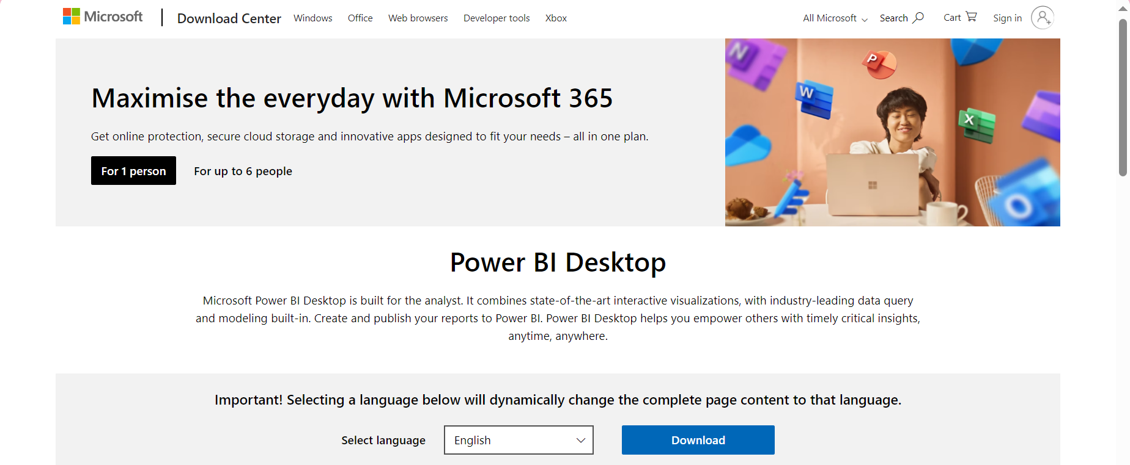

1. Select x64 option and download

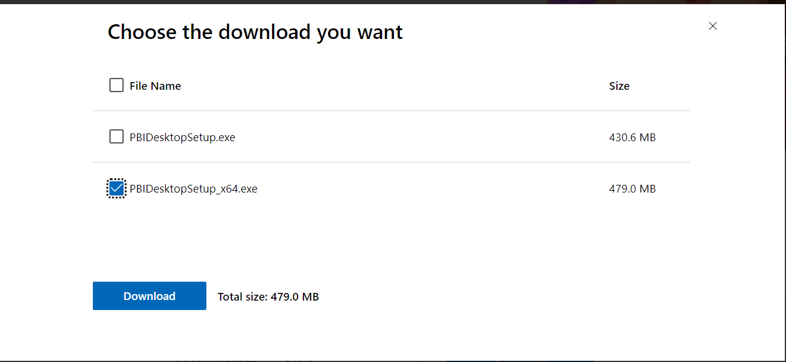

1. Finally, Install the Power BI Software in your Laptop.